Homework 4: Packaging Specifications and Design
Due: Friday, September 21, at NOON

Team Code Name: Hooked on Harmonix Group No. 2
Team Member Completing This Homework: Curtis Verner
e-mail Address of Team Member: cverner @ purdue.edu
NOTE: This is the first in a series of four “design component” homework assignments, each of which is to be completed by one team member. The completed homework will count for 20% of the individual component of the team member’s grade. The body of the report should be 3-5 pages, not including this cover page, references, attachments or appendices.

Evaluation:

SCORE | DESCRIPTION
10 | Excellent – among the best papers submitted for this assignment. Very few corrections needed for version submitted in Final Report.
9 | Very good – all requirements aptly met. Minor additions/corrections needed for version submitted in Final Report.
8 | Good – all requirements considered and addressed. Several noteworthy additions/corrections needed for version submitted in Final Report.
7 | Average – all requirements basically met, but some revisions in content should be made for the version submitted in the Final Report.
6 | Marginal – all requirements met at a nominal level. Significant revisions in content should be made for the version submitted in the Final Report.
* | Below the passing threshold – major revisions required to meet report requirements at a nominal level. Revise and resubmit.
* Resubmissions are due within one week of the date of return, and will be awarded a score of “6” provided all report requirements have been met at a nominal level.

Comments:
- Introduction
The Hooked on Harmonix game system provides the user with an interactive keyboard playing experience that helps develop musical and rhythm skills by scrolling notes on a VGA monitor and playing the song over speakers while grading the user’s performance as he attempts to play along with the song. The three major high level components of the Hooked on Harmonix system are the MIDI keyboard, VGA LCD display with built in speakers, and the enclosed circuitry unit. The user will provide the input to the Hooked on Harmonix system with a MIDI keyboard through a MIDI cable connected to the circuitry unit, which will perform all game play logic and output the appropriate video and audio signals to the monitor and speakers. The MIDI keyboard and monitor will not be packaged with the circuitry unit, but rather they will be connected with the appropriate cables and connectors. The circuitry unit will be packaged in an enclosure that will rest on whatever surface is supporting the monitor.

- Commercial Product Packaging
The top two commercial products similar to the Hooked on Harmonix system are I can Play! Piano by Fisher Price and Piano Wizard by Allegro Rainbow. These two products differ slightly in their packaging approach, with unique advantages and disadvantages.

  - Product #1 – “I Can Play! Piano” by Fisher Price
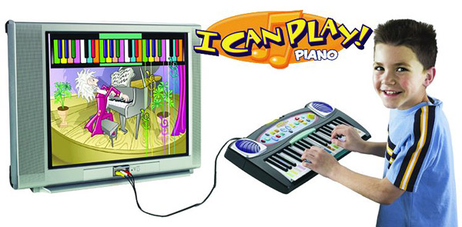
Figure 1. “I Can Play! Piano” Packaging Example
The “I can Play! Piano” is packaged as a standalone MIDI keyboard with an audio and video NTSC television output. [1] The keyboard packaging houses all of the circuitry, which provides the functionality both for the MIDI keyboard itself and for the interactive video game played on the television. The advantage to this packaging approach is that the only additional equipment necessary to play the “I Can Play! Piano” is a television set. It is not necessary to interface the keyboard with a personal computer and to install separate software. The disadvantage of this packaging method is that the product can not easily interface to peripherals for the user to add custom songs or content. Additional songs can be added through expansion cartridges, but the song selection is limited to available cartridges. [1] The user is limited to playing the song selection chosen by the manufacturer.

  - Product #2 – “Piano Wizard” by Allegro Rainbow
The Piano Wizard is packaged differently than the Fisher Price “I Can Play! Piano” with the most complete package including a stand alone 49 key MIDI keyboard, a MIDI to USB converter, piano wizard software, and a set of colored stickers to be placed on your keys. [2]
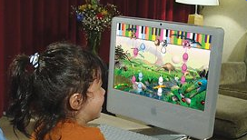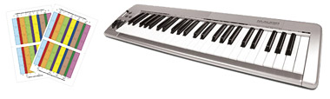
Figure 2. “Piano Wizard” Packaging Example
The game is displayed over the computer monitor attached to the PC (or Mac) running the software. The main advantage of this packaging design is that any MIDI keyboard can be connected to the computer to interface with the software. This gives the user flexibility when choosing a MIDI keyboard, because any MIDI keyboard will function with the system. Also having the game run on a computer allows the possibility of adding additional songs to the game library and updating the software.
The newest version of “Piano Wizard”, “Piano Wizard Premier”, allows the user to upload any MIDI song file desired into the program so that the user can play the song. [2] The ability to add songs to the program is a feature that is possible due to the flexible PC based packaging design, which provides the interface necessary to load MIDI files into the program.

- Project Packaging Specifications
The Hooked on Harmonix system will be packaged in a manner to maximize the advantages of both of the aforementioned products, while minimizing their disadvantages. The Hooked on Harmonix system circuitry will be packaged in a small box enclosure with the dimensions 4x6x1.8 inches (see Appendix A). This box will house the populated PCB board with all of the components necessary to run the Hooked on Harmonix system apart from the MIDI keyboard, LCD monitor, and speakers. The box enclosure will have 5 openings milled on the front and 3 on the back. The front openings of the enclosure will allow access to USB and MIDI ports as well as a power switch, a tempo adjustment knob, and a power on indicator LED. The rear openings will provide access to the power connector, the VGA monitor connector, and the audio jack. These openings will require a 5/16” drill bit for the power connector, ½” bit for the VGA D-Sub connector, ¼” bit for the audio jack and tempo knob axle, ¾” bit for the MIDI connector, 1/8th bit for the LED, and 5/16” bit for the USB port (see Appendix B). The rectangular openings will be drilled with the appropriate bit size and then shaped appropriately with available tools.
There are many advantages to having a standalone box enclosure with convenient I/O capabilities. This packaging method will provide the advantages of upgradability and song expansion via the USB port and serial port. The packaging will also allow a user without a computer to utilize the system. In this way, the Hooked on Harmonix system packaging incorporates the advantages of both the “I Can Play! Piano” and the “Piano Wizard” products.

- PCB Footprint Layout
The major component selected for the Hooked on Harmonix system was the Cyclone II FPGA with an embedded soft core NIOS II processor. The Cyclone II FPGA comes in various shapes and sizes with models ranging from 144 pins in the EP2C5 model to 896 pins in the EP2C70 model. [3] The PCB footprints for these various models also differ greatly. When making the decision regarding the Cyclone II model selection, several main factors were considered. The first factor considered was our limited manufacturing and soldering resources. Due to lack of the necessary equipment, all of the Cyclone II FPGA models available only in BGA type packages had to be ruled out of the design. Another important consideration for the FPGA was having a sufficient number of I/O pins available to interface with the many various peripherals of the system. After carefully examining the candidate parts, the EP2C35 model was chosen with the 240pin PQFP package option. This Cyclone II model has the most I/O pins of any of the non-BGA packaged models. The PQFP packaging option was an easy decision as it was the only feasible option given the limited manufacturing resources available to the team. The size of the FPGA footprint was not a factor in determining which part to use in the design, because the size of the PCB is not a major constraint for the project. The initial estimate for the PCB size after dimensioning all major components is 5 x 4 inches. (See Appendix C) The packaging enclosure dimensions detailed in section 3.0 were estimated from this PCB size.

- Summary
The advantages of the packaging design of two similar commercial products were carefully examined in order to optimize the packaging design for the Hooked on Harmonix system. The Hooked on Harmonix system packaging design implements the convenience of a standalone, non-computer based product such as the “I Can Play! Piano” along with the song expandability of a PC based product such as “Piano Wizard.” Because the PCB will be approximately 4x5 inches, the packaging design for Hooked on Harmonix processing unit consists of a 4x6x1.8 inch enclosure box with milled openings to provide access to the various device interfaces. The MIDI keyboard and Monitor will interface to this box to complete the Hooked on Harmonix system.
List of References

- Fisher Price. (2007) I Can Play! Piano. Available: http://www.fisher-price.com/fp.aspx?st=2640&e=product&pid=35911 [Accessed September 19, 2007]

- Allegro Rainbow. (2007) Piano Wizard PREMIER Keystation 49e Package. Piano Wizard. Available: http://www.pianowizard.com/purchase.php [Accessed September 19, 2007]

- Altera. (2007) Literature: Cyclone II Devices. Available: http://www.altera.com/literature/lit-cyc2.jsp [Accessed September 20, 2007]

Appendix A: Project Packaging Illustrations

Figure 3. Enclosure Packaging Dimensions

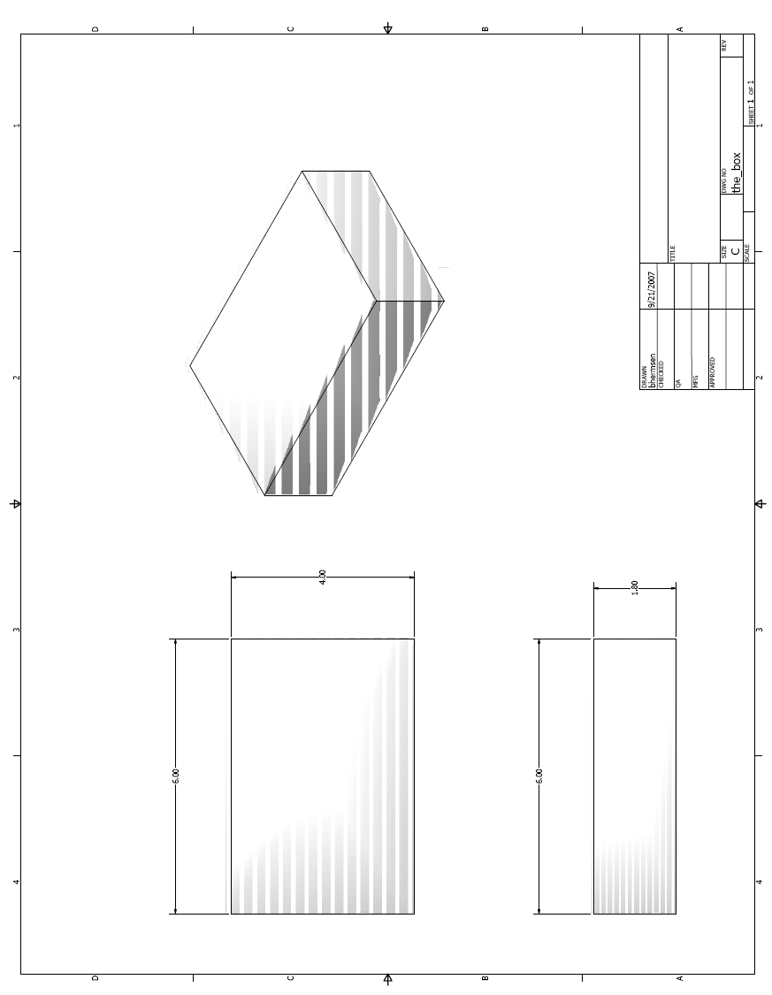
Appendix B: Project Packaging Specifications

Figure 4. Packaging Materials

Material | Unit Weight (est.) | Manufacturer | Unit Cost
Plastic Enclosure Box | 4 oz. | Polycase | $7.18

Figure 5. Tooling Requirements

Part | Part Number | Manufacturer | Tooling Drill Size
DC 9V Power Connector | 16PJ031 | Kobiconn | 5/16”
VGA D-Sub Connector | 09 56 152 7612 | Harting | 1/2”
3.5 mm Audio Jack | 161-3507 | Kobiconn | 1/4”
Tempo Knob | RB | BI Technologies | 1/4”
5 Pin Din Connector (MIDI) | SDS-50J | CUI | 3/4”
Power Indicator LED | WP934CB/GD | Kingbright | 1/8”
USB port (Type A) | 87531-0001 | MOLEX | 5/16”

Appendix C: PCB Footprint Layout

Figure 6. Major Component PCB Footprint Layout

